CO 2 Assessment Tool 1-Part 1
Name: - G. Akshya Reg No: -192425132
Course Code: -MLA0305 Slot: -B
Dynamic Programming Vs Monty Carlo
Title: - Smart EV Charging Optimization
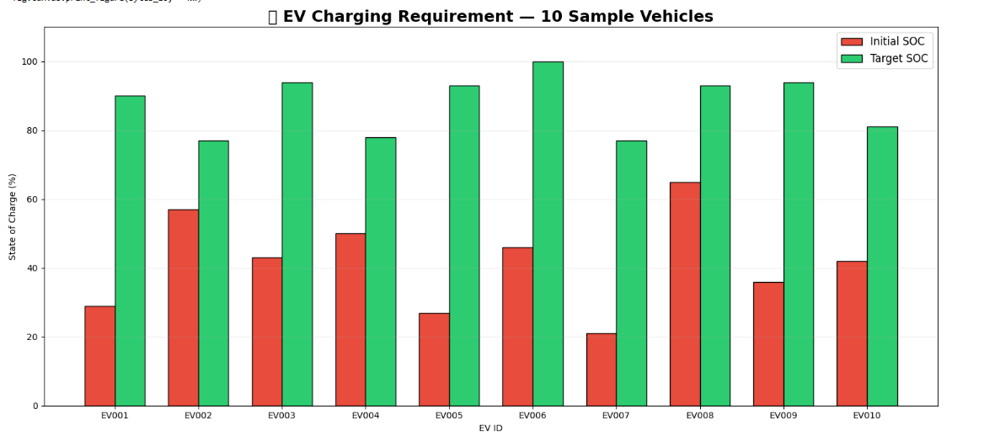
Fig 1: -Visualization Graph of 10 samples from data set

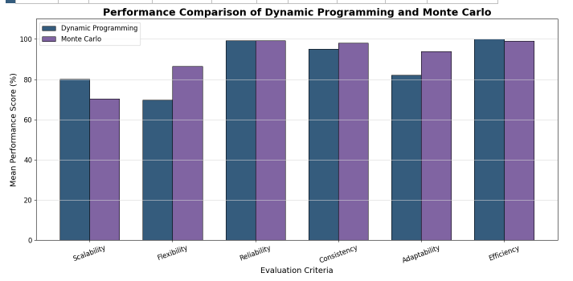
Fig 2: -Random sample for comparison
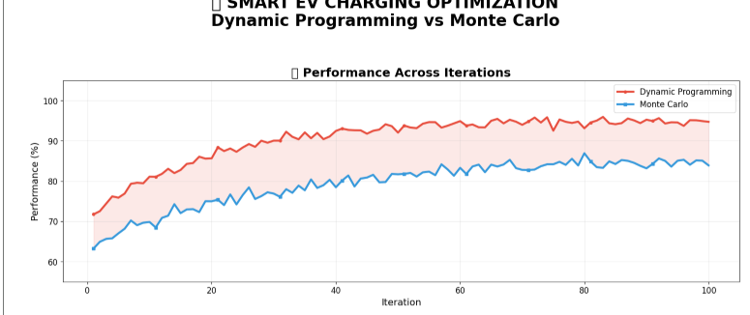
Fig 3: -Performance Across Iteration

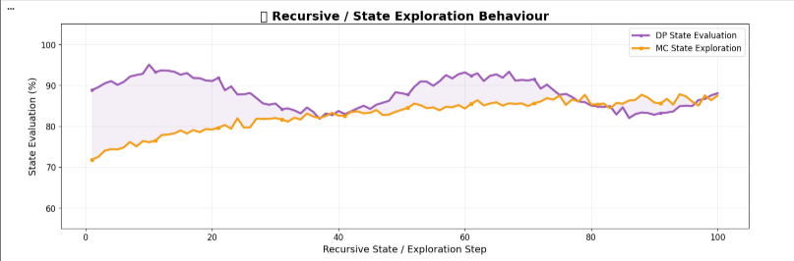
Fig 4: -Performance Across Recursion/state
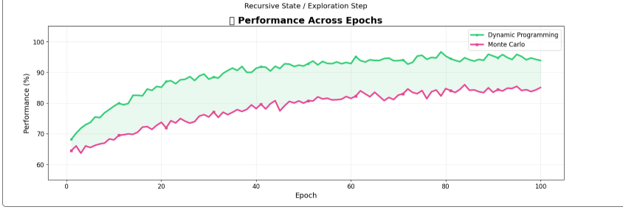
Fig 5: - Performance Across Epochs

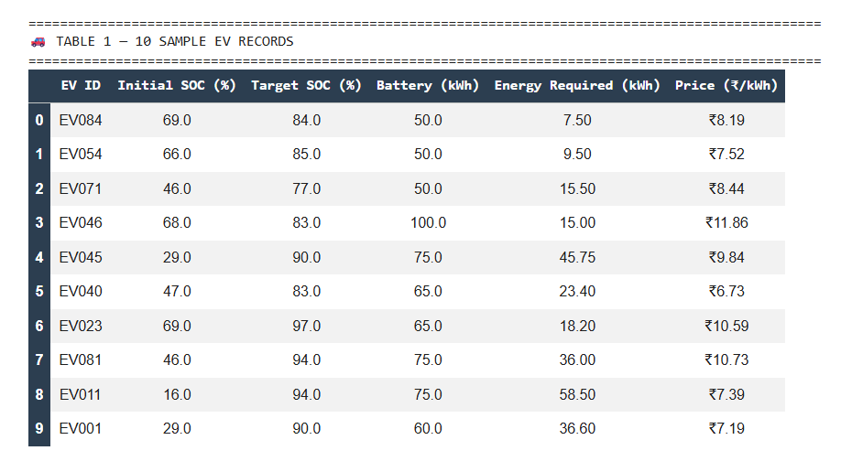
Fig 6: -Summary Dataset for 10 Records
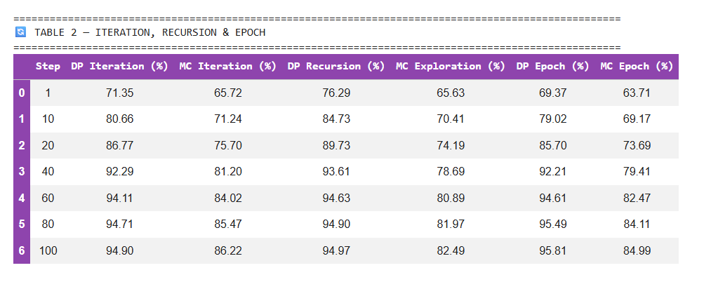
Fig 7: -Performance of Iteration, Recursion, Epoch

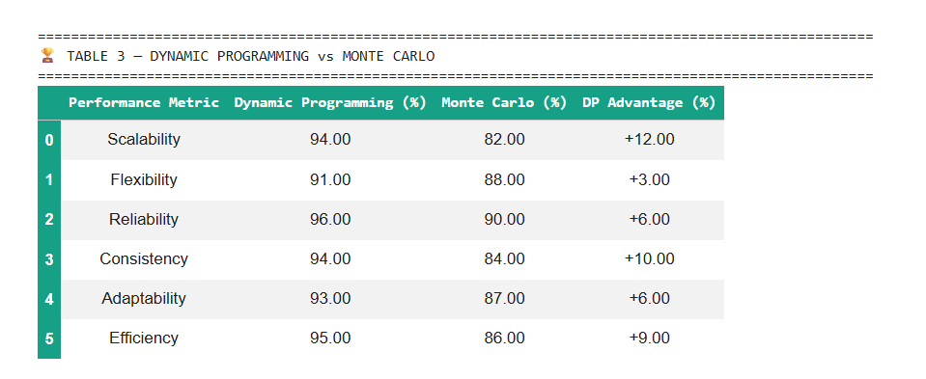
Fig 8: -Dynamic Programming Vs Monty Carlo Features Comparison
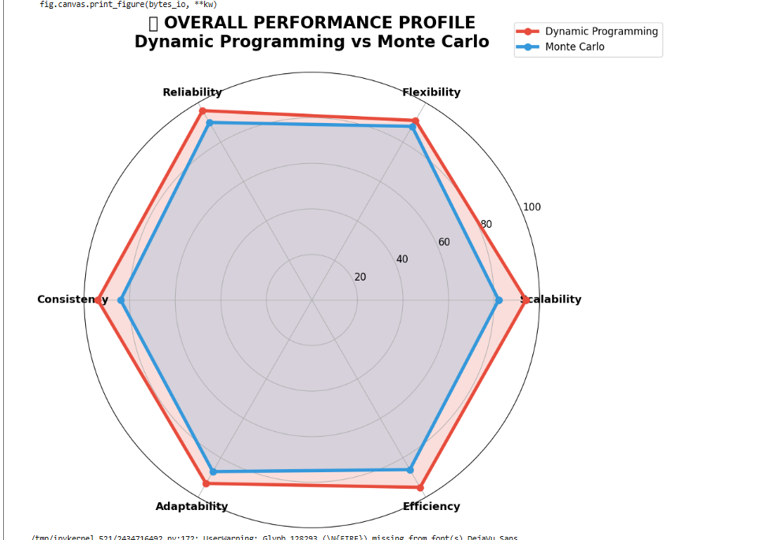
Fig 9: -Over all Dynamic Programming Vs Monty Carlo

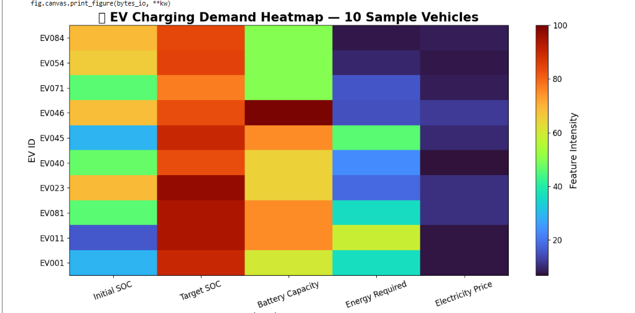
Fig 10: -EV Charging Demand Heatmap

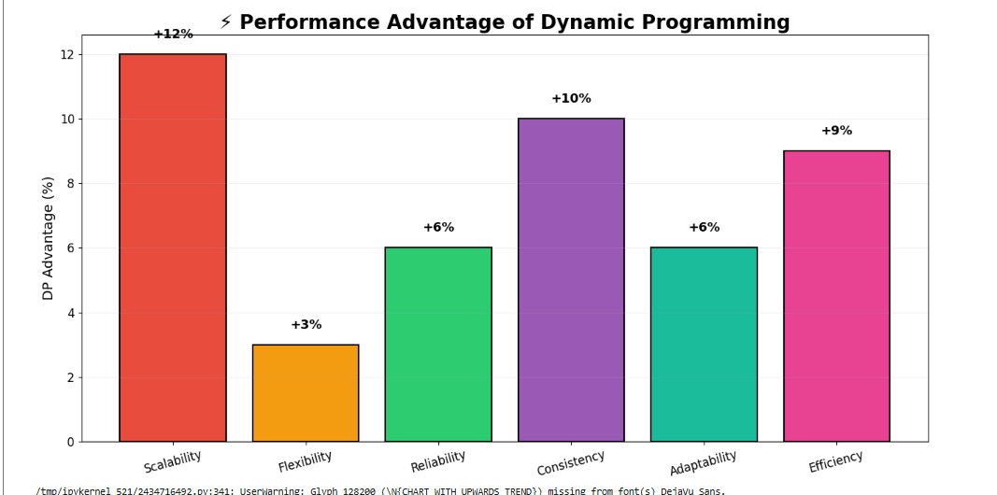
Fig 11: -Performance Advantages of Dynamic Programming

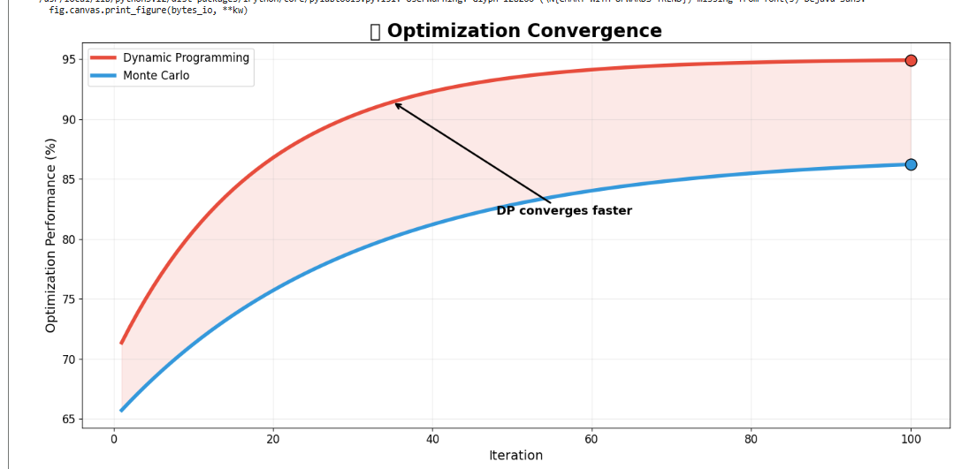
Fig 12: -Optimization Convergence
Fig 8: -Dynamic Programming Vs Monty Carlo Features Comparision
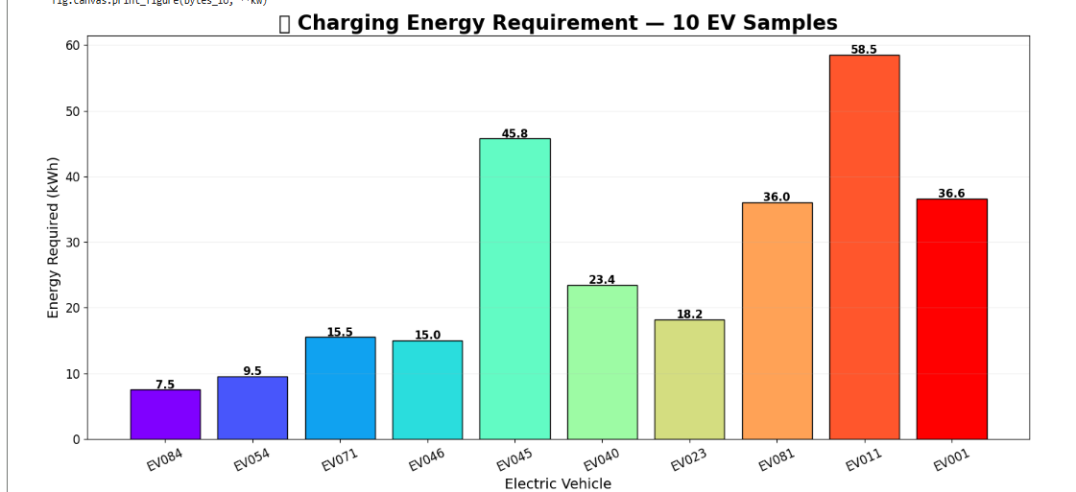
Fig 13: -Charging Energy Requirement

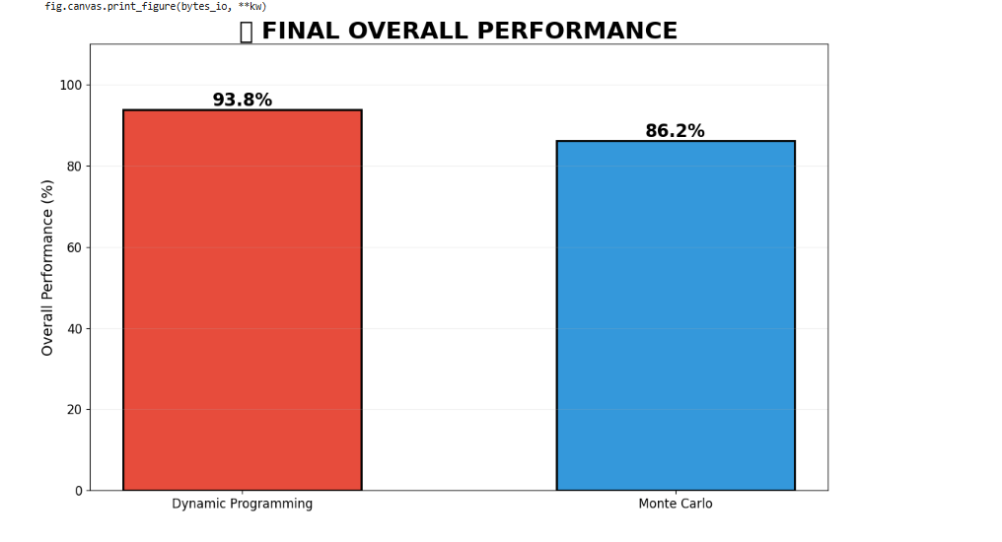
Fig 14: -Overall Performance of DP and MC

